ISLAMIC UNIVERSITY OF TECHNOLOGY
DHAKA, BANGLADESH
ORGANIZATION OF ISLAMIC COOPERATION
DATABASE MANAGEMENT SYSTEMS LAB

Name: Antara Arifa Mullick
Student ID: 210042132
Department: Computer Science and Engineering
Program: B.Sc. in Software Engineering

Report preparing for Lab Task

Here is the problem statement -
Execute the banking.sql script using command. It creates a set of tables along with values that
maintain the following schema:
Here, the boldfaces denote the primary keys and the arcs denote the foreign key relationships.
In this lab, you have to write all SQL statements in an editor first and save them with .sql extension.
Then execute the SQL script.
Write SQL statements for the following queries:
1.Find all customer names and their cities who have a loan but not an account.
Solution Approach
select distinct
c.customer_name,c.customer_city
from customer c
join borrower b on
c.customer_name= b.customer_name
where c.customer_name NOT
in(select distinct customer_name
from depositor
);

SQL Command
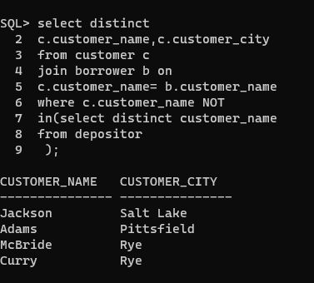

2.Find all customer names who have an account as well as a loan.
Solution Approach

SELECT CUSTOMER_NAME
FROM CUSTOMER
WHERE CUSTOMER_NAME IN( SELECT CUSTOMER_NAME FROM BORROWER)AND
CUSTOMER_NAME IN(
SELECT CUSTOMER_NAME FROM DEPOSITOR
);
SQL Command
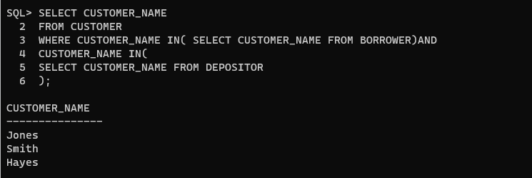
3. Show the count of accounts that were opened in each month along with the month.
Solution Approach

SELECT TO_CHAR(acc_opening_date, 'MM') AS month, COUNT(*) AS account_count
FROM account
GROUP BY TO_CHAR(acc_opening_date, 'MM')
ORDER BY TO_CHAR(acc_opening_date, 'MM');
SQL Command
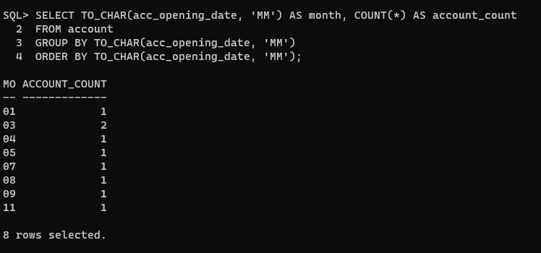
4. Find the months between the last acc_opening_date and last loan_date of customer ’Smith’.
Solution Approach

select months_between(
(select max(acc_opening_date)
from account
where account_number in(
select account_number
from depositor
where customer_name = 'Smith')),
(select max(loan_date)
from loan
where loan_number in(
select loan_number
from borrower
where customer_name = 'Smith'
)))
as month
from dual;
SQL Command
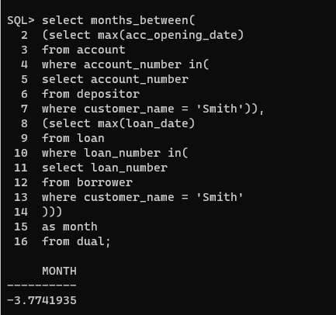

5. Find the average loan amount at each branch. Do not include any branch which is located in a that has the substring, ’Horse’ in its name.
Solution Approach

SELECT B.BRANCH_NAME, AVG(L.AMOUNT) AS
AVERAGE_LOAN_AMOUNT
FROM BRANCH B
JOIN LOAN L ON B.BRANCH_NAME = L.BRANCH_NAME
WHERE B.BRANCH_CITY NOT LIKE '%HORSE%'
GROUP BY B.BRANCH_NAME;
SQL Command
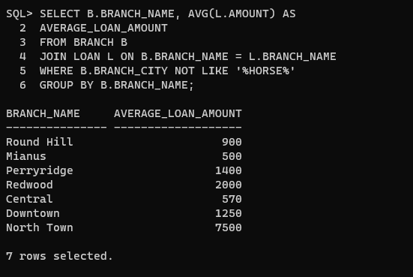
6. Find the customer name and account number of the account that has the highest balance.
Solution Approach

SELECT D.CUSTOMER_NAME, D.ACCOUNT_NUMBER,
A.BALANCE FROM DEPOSITOR D
JOIN ACCOUNT A ON D.ACCOUNT_NUMBER = A.ACCOUNT_NUMBER WHERE A.BALANCE =
(SELECT MAX(BALANCE) FROM ACCOUNT
);
SQL Command
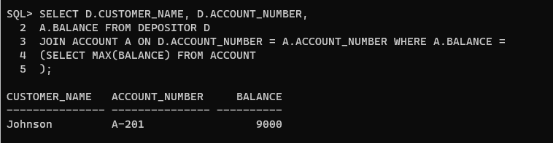
7. For each branch city, find the average amount of all the loans opened in a branch located in that branch city. Do not include any branch city in the result where the average amount of all loans opened in a branch located in that city is less than 1500.
Solution Approach

SELECT B.BRANCH_CITY,
AVG(L.AMOUNT) AS AVERAGE_CITY_LOAN FROM BRANCH B
JOIN LOAN L ON B.BRANCH_NAME = L.BRANCH_NAME GROUP BY B.BRANCH_CITY HAVING
AVG(L.AMOUNT) >= 1500;

SQL Command
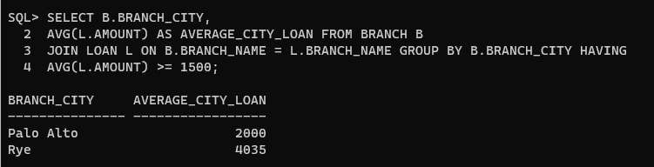

8.Show all the name of the customer with the suffix ’Eligible’ who has at least one loan that can be paid off by his/her total balance.
Solution Approach

select customer_name || ' Eligible'
as customer_name from depositor
where account_number in
(select account_number from account
where balance >=
(select sum(amount) from loan
where loan.branch_name = account.branch_name
and loan.loan_number in
(select loan_number from borrower
where borrower.customer_name = depositor.customer_name)
)
);
SQL Command
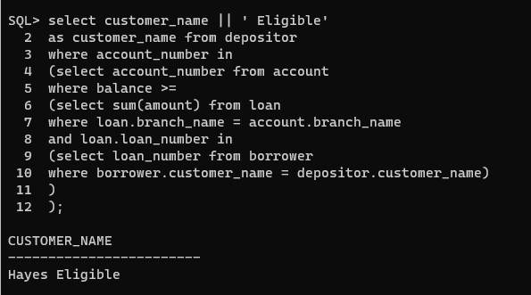
9. Show all the branch names with suffixes ’Elite’ that have a total account balance greater than the (average total balance + 500), ’Moderate’ that have a total account balance in between (average total balance + 500) to (average total balance - 500), else ’Poor’.
Solution Approach

Show all the branch names with suffixes ’Elite’ that have a total account balance greater than the (average total balance + 500), ’Moderate’ that have a total account balance in between (average total balance + 500) to (average total balance - 500), else ’Poor’.
SELECT branch_name || ' Elite' AS branch_name from branch
where branch_name in
(
select branch_name from account
group by branch_name
having sum(balance) >
(
select avg(sum_balance) + 500 from
(
select branch_name, sum(balance) as sum_balance from account
group by branch_name
)
)
)
UNION
SELECT branch_name || ' Moderate' AS branch_name from branch
where branch_name in
(
select branch_name from account
group by branch_name
having sum(balance) between
(
select avg(sum_balance) + 500 from
(
select branch_name, sum(balance) as sum_balance from account
group by branch_name
)
)
and
(
select avg(sum_balance) - 500 from
(
select branch_name, sum(balance) as sum_balance from account
group by branch_name
)
)
)
UNION
SELECT branch_name || ' Poor' AS branch_name from branch
where branch_name in
(
select branch_name from account
group by branch_name
having sum(balance) <
(
select avg(sum_balance) - 500 from
(
select branch_name, sum(balance) as sum_balance from account
group by branch_name
)
)
);

SQL Command
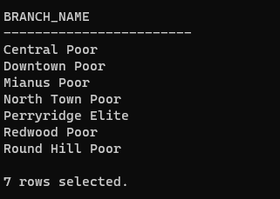
10. Find the branch information for cities where at least one customer lives who does not have any account or any loans. The branch must have given some loans and has accounts opened by other customers.
Solution Approach

SELECT branch_name, branch_city from branch
where branch_city in
(
select customer_city from customer
where customer_city not in
(
select customer_city from customer
where customer_name in
(
select customer_name from depositor
)
or
customer_name in
(
select customer_name from borrower
)
)
)
and branch_name in
(
select branch_name from loan
group by branch_name
having count(*) > 0
)
and branch_name in
(
select branch_name from account
group by branch_name
having count(*) > 0
);

SQL Command
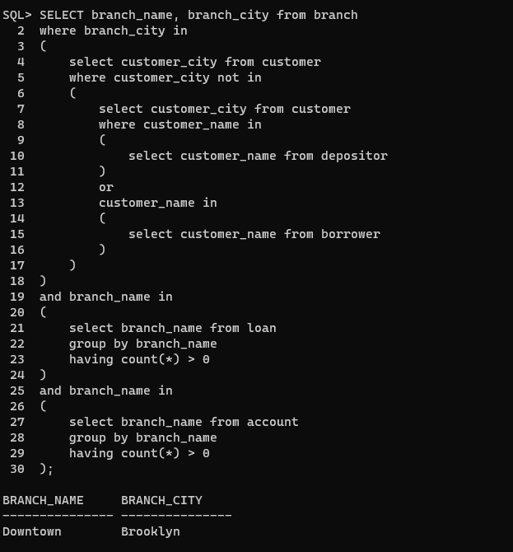
11.Create a new customer_new table using a similar structure to the customer table.
Solution Approach

CREATE TABLE customer_new AS
SELECT * FROM customer
where customer_name = 'dog';

SQL Command
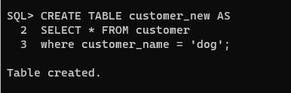
12. In the customer_new table insert only those customers who have either an account or a loan.
Solution Approach

INSERT INTO customer_new
SELECT * FROM customer
where customer_name in
(
select customer_name from depositor
)
or
customer_name in
(
select customer_name from borrower
);
SQL Command
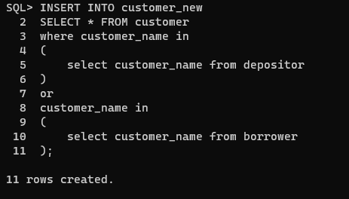
13.Add a new column Status in customer_new table of varchar2(15) type.
Solution Approach

ALTER TABLE customer_new
ADD status VARCHAR2(15);
SQL Command
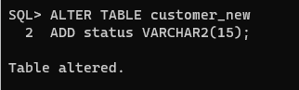
14. For each customer if his/her total balance is greater than the total loan then set the status ’In savings’, if the vise versa then ’In loan’, lastly if both of the amounts are the same then ’In Breakeven’.
Solution Approach

UPDATE customer_new
SET Status = (
CASE
WHEN (
SELECT SUM(a.balance)
FROM account a
WHERE EXISTS (
SELECT 1
FROM depositor d
WHERE d.customer_name = customer_new.customer_name
AND d.account_number = a.account_number
)
) > (
SELECT SUM(l.amount)
FROM loan l
WHERE EXISTS (
SELECT 1
FROM borrower b
WHERE b.customer_name = customer_new.customer_name
AND b.loan_number = l.loan_number
)
) THEN 'In Savings'
WHEN (
SELECT SUM(a.balance)
FROM account a
WHERE EXISTS (
SELECT 1
FROM depositor d
WHERE d.customer_name = customer_new.customer_name
AND d.account_number = a.account_number
)
) < (
SELECT SUM(l.amount)
FROM loan l
WHERE EXISTS (
SELECT 1
FROM borrower b
WHERE b.customer_name = customer_new.customer_name
AND b.loan_number = l.loan_number
)
) THEN 'In Loan'
ELSE 'In Breakeven'
END
);

SQL Command
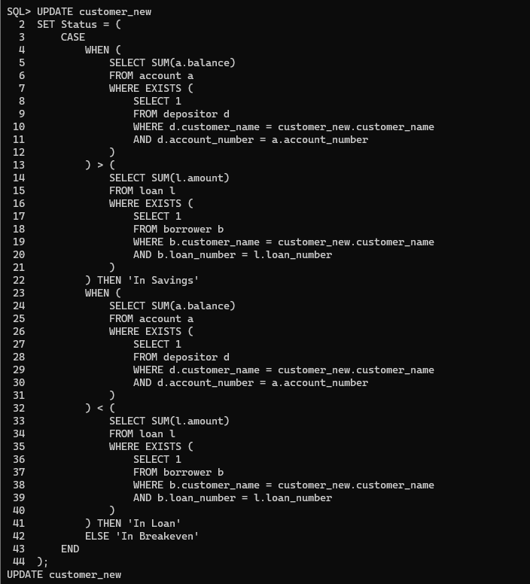
15. Count the occurrences of each status type in customer_new table.
Solution Approach

SELECT status, COUNT(*) as status_count
FROM customer_new
GROUP BY status;

SQL Command
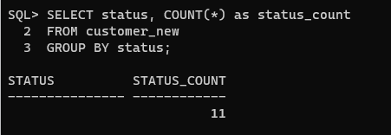
Problems faced :
Syntax Errors: SQL queries must have some strict syntax requirements. Incorrectly worded queries might result in syntax problems and as a beginner I did struggle to get the syntax properly.
Understanding Database Structure: As I was not so familiar with the structure of the database I am working with, it might be difficult to determine which tables exist, what columns they include, and how they relate to one another.
Table Creation: Creating tables with the right structure and data types were a bit tricky. Defining primary keys,Foreign keys, and constraints correctly is essential.
Connect Table : to connect multiple table command is a bit difficult to me.

